RESOURCES

- To Mask or Not to Mask
Prepared by Health Ministries, Ontario Conference of Seventh-day Adventists
Principal Sources: Public Health Agency of Canada, Centres for Disease Control and Prevention, World Health Organization, Centre for Addiction and Mental Health, https://www.adventhealth.com
COVID-19 is transmitted through nasal and respiratory secretions, usually by sneezing or coughing on people directly, or by secretions going on surfaces that other people touch and then rub into their eyes, nose, or mouth. People can transmit the infection in the 48 hours before they show symptoms (pre-symptomatic transmission) or when they have the infection and show no symptoms at all (asymptomatic transmission). (Public Health Agency of Canada, Centres for Disease Control and Prevention, World Health Organization)
At the beginning of the pandemic, the coronavirus was so new that doctors were unsure of the extent to which wearing cloth face coverings or homemade masks - compared with medical-grade surgical or N95 masks - would help prevent the virus from spreading. Studies have since suggested, however, that a mask over the nose and mouth works as a physical barrier against respiratory droplets that can carry and spread the coronavirus. Additional studies have indicated that viral load peaks in the days before symptoms begin and that speaking is enough to expel virus-carrying droplets. While it important to wear a mask to reduce the spread of COVID-19, mask wearing cannot guarantee protection from the virus and should not replace proven measures such as frequent handwashing, avoiding touching your eyes, nose or mouth with unwashed hands, practising physical distancing and staying at home if you are sick. (Public Health Agency of Canada, Centres for Disease Control and Prevention, World Health Organization)
As more businesses and public spaces open and people increase their contacts and movement, it increases the risk of a rapid rise in infections and outbreaks. Therefore, mandatory use of face masks in indoor public settings has become necessary in order to continue to slow or stop the spread of infection. (Toronto Public Health)
(Note: Both the CDC and WHO still only recommend N95 respirator masks for "health care personnel (HCP) who need protection from both airborne and fluid hazards." Guidelines for health care personnel, first responders, etc. are not covered in this resource.
There are many in Christian communities who object to wearing masks. There is no biblical reason for this. On the contrary, following instructions for personal and public safety (similar to wearing seatbelts, obeying traffic signals, washing hands and maintaining the recommended physical distance to help control the spread of COVID-19, etc.) demonstrates responsible and mature Christian citizenship. God, himself, provided the Israelites with infection control guidelines that were designed to prevent and/or contain epidemics (See Leviticus 11-15, Deuteronomy 23:12,13, etc.). Please note additional information on this area in this excerpt from For Your Health, by Ángel Manuel Rodríguez : https://adventistbiblicalresearch.org/materials/health/your-health
Principles of Hygiene: We also find, embedded in the ritual laws, principles of hygiene. A few examples may suffice. We already mentioned the prohibition of touching a corpse or the carcass of an animal (cf. Lev. 17:15). Water played an important role after a person came into contact with the unclean, even in cases in which a sick person spat on someone else (Lev. 15:7, 8). Water removed the contagion. Isolation or quarantine was also practiced to prevent the spread of the unclean (e.g., Num. 31:21-24), which in some cases included particular diseases (e.g., Lev. 15:26, 27). The proper disposition of human excrement was legislated to prevent the spread of infectious diseases and probably to eliminate odors (Deut. 23:12-14).
- For additional commentary on masks, please note the following from https://www.toronto.ca

Non-medical masks and face coverings - How to protect others
The best thing you can do to prevent spreading COVID-19 is to wash your hands frequently with warm water and soap for at least 20 seconds. If none is available, use hand sanitizer containing at least 60% alcohol.
To protect others, you should also:
- stay at home if you are ill
- maintain a 2-metre physical distance from others
  - when physical distancing cannot be maintained, consider wearing a non-medical mask or homemade face covering
- avoid touching your face, mouth, nose or eyes
Wearing a homemade non-medical mask/facial covering in the community is recommended for periods of time when it is not possible to consistently maintain a 2-metre physical distance from others, particularly in crowded public settings, such as:
- stores
- shopping areas
- public transportation
Public health officials will make recommendations based on a number of factors, including the rates of infection and/or transmission in the community. In some jurisdictions, the use of masks in many indoor public spaces and on public transit is now mandatory. You can check with your local public health authority on the requirements for your location.
Wearing a mask alone will not prevent the spread of COVID-19. You must consistently and strictly adhere to good hygiene and public health measures, including frequent hand washing and physical (social) distancing.

Appropriate use of non-medical mask or face covering
When worn properly, a person wearing a non-medical mask or face covering can reduce the spread of his or her own infectious respiratory droplets.
Non-medical face masks or face coverings should:
- allow for easy breathing
- fit securely to the head with ties or ear loops
- maintain their shape after washing and drying
- be changed as soon as possible if damp or dirty
- be comfortable and not require frequent adjustment
- be made of at least 2 layers of tightly woven material fabric (such as cotton or linen)
- be large enough to completely and comfortably cover the nose and mouth without gaping
Some masks also include a pocket to accommodate a paper towel or disposable coffee filter, for increased benefit.
Non-medical masks or face coverings should:
- not be shared with others
- not impair vision or interfere with tasks
- not be placed on children under the age of 2 years
- not be made of plastic or other non-breathable materials
- not be secured with tape or other inappropriate materials
- not be made exclusively of materials that easily fall apart, such as tissues
- not be placed on anyone unable to remove them without assistance or anyone who has trouble breathing

COVID-19: How to safely use a non-medical mask or face covering
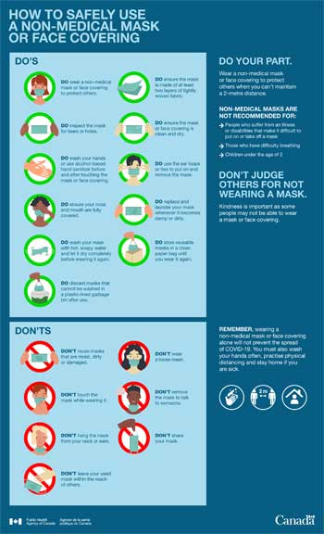

DOs
- DO wear a non-medical mask or face covering to protect others.
- DO ensure the mask is made of at least two layers of tightly woven fabric.
- DO inspect the mask for tears or holes.
- DO ensure the mask or face covering is clean and dry.
- DO wash your hands or use alcohol-based hand sanitizer before and after touching the mask or face covering.
- DO use the ear loops or ties to put on and remove the mask.
- DO ensure your nose and mouth are fully covered.
- DO replace and launder your mask whenever it becomes damp or dirty.
- DO wash your mask with hot, soapy water and let it dry completely before wearing it again.
- DO store re-usable masks in a clean paper bag until you wear it again.
- DO discard masks that cannot be washed in a plastic lined garbage bin after use.

Don'ts
- DON'T reuse masks that are moist, dirty or damaged.
- DON'T wear a loose mask.
- DON'T touch the mask while wearing it.
- DON'T remove the mask to talk to someone.
- DON'T hang mask from your neck or ears.
- DON'T share your mask.
- DON'T leave your used mask within the reach of others.
Remember, wearing a non-medical mask or face covering alone will not prevent the spread of COVID-19. You must also wash your hands often, practise physical distancing and stay home if you are sick.
Do your part. Wear a non-medical mask or face covering to protect others when you can't maintain a 2 metre distance.

Can you be medically exempt from wearing a face mask? – www.health.com

Dear non-maskers: An open letter from a person with CF (Cystic fibrosis) - https://www.geisinger.org/health-and-wellness/wellness-articles/2020/07/16/12/14/open-letter-on-face-masks

- From Stephen Spohn: As someone with a profound disability, it's disgusting to me that people are using the Americans With Disabilities Act of 1990 to justify avoiding a minor inconvenience These badly misspelled cards & their card-carrying members are using disabled people as shields to harm others. If wearing a mask makes you feel humiliated, try the first few months of wearing a ventilator.
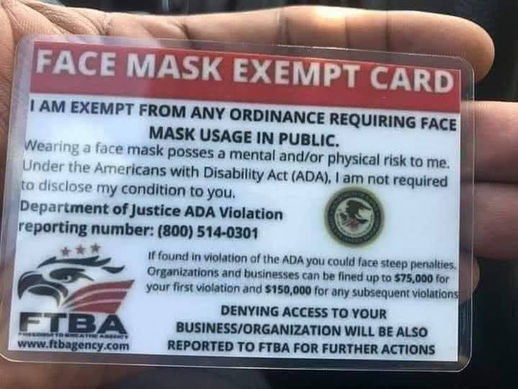
- Please note the summary on masks provided below for your convenience.
Public Health Agency of Canada - https://www.canada.ca/en/public-health.html

For additional information on face shields, exemptions, objections, myths about face masks, and other pertinent topics, please check the following:

https://www.adventhealth.com/coronavirus-resource-hub/search?query=mental+health+and+COVID-19&cat=global

God’s Promises in Crises

Isaiah 43

¹But now, O Jacob, listen to the LORD who created you.
O Israel, the one who formed you says,
Do not be afraid, for I have ransomed you.
I have called you by name; you are mine.
²When you go through deep waters,
I will be with you.
When you go through rivers of difficulty,
you will not drown.
When you walk through the fire of oppression,
you will not be burned up;
the flames will not consume you.
³For I am the LORD, your God,
the Holy One of Israel, your Savior.
you are precious to me.
You are honored, and I love you.
⁵“Do not be afraid, for I am with you.
¹³“From eternity to eternity I am God.
No one can snatch anyone out of my hand.
No one can undo what I have done.

Psalm 23:4 I may walk through valleys as dark as death, but I won’t be afraid.
You are with me, and your shepherd’s rod makes me feel safe.
Isaiah 41:10 - Don’t be afraid, for I am with you. Don’t be discouraged, for I am your God. I will strengthen you and help you. I will hold you up with my victorious right hand.

Philippians 4:6-7 ⁶ Don’t worry about anything; instead, pray about everything. Tell God what you need, and thank him for all he has done. ⁷ Then you will experience God’s peace, which exceeds anything we can understand. His peace will guard your hearts and minds as you live in Christ Jesus.

Why Gratitude Is Important During the Coronavirus Pandemic www.adventhealth.com

We’re living through unusual and trying times. The COVID-19 pandemic has people feeling stressed and frightened. That’s why it’s perhaps more important than ever to focus on gratitude — the practice of noticing and being thankful for what is valuable and meaningful to you. It’s good for your mental and physical health, it can help you relax and its effects can help you stay well through the coronavirus pandemic and beyond.
Yes, We Said Gratitude Is Good for Your Health
Focusing on silver linings. Counting your blessings. Stopping to smell the roses.
These aren’t just clichés; they’re activities that research shows may enhance your quality of life. The health benefits of practicing gratitude are wide-ranging — and maybe even a bit surprising.
- Improving your immune system. The practice of gratitude can improve immune function, according to the American Heart Association. This is especially important during the COVID-19 crisis, since people with compromised immune systems face a high risk of becoming severely ill from coronavirus.
- Lowering your risk for mental health issues. Studies have shown that people who practiced gratitude showed a significantly lower risk for major depression, generalized anxiety disorder and substance dependence and abuse, according to the National Alliance on Mental Illness.
- Getting a handle on stress. Focusing on positive emotions can help improve your ability to cope with stress, according to the National Institutes of Health.
- Setting yourself up for success. In clinical trials, grateful people have been shown to exercise more and eat healthier diets.
Practicing Gratitude Can Be Easy, Rewarding — And Fun
Cultivating thankfulness isn’t homework, and it doesn’t require much time or energy. You can start small by taking a few moments to notice things that are going well in your life.
To help make this a regular habit, set aside a short time each day to intentionally practice gratitude. Try one or more of these activities to start.
Jot Down Your Joys
Make a habit of writing down the things you’re grateful for. It doesn’t have to be a long list, but if you regularly challenge yourself to identify and name your gratitude, you may begin to notice improvement in your emotional well-being.
Try sitting down and listing out:
- One place that is safe and relaxes you
- One thing that’s going well in your life
- Three things you enjoy
- Three things you’re looking forward to
- Two people whom you love and who love you
Or try an easy-to-remember acronym, HEART, as suggested by the American Heart Association:
- Health: Think of what your body allowed you to do today. Maybe your feet enabled you to walk around the house or your arms allowed you to hold a pet you love.
- Eat: What nourishment did you provide your body today? What was your favorite meal?
- Activity: Did you do something today that you really enjoyed? Take a moment to reflect on and savor it.
- Relationship: Did you see or talk to someone today who brings you joy? Or are you planning to see someone on a video chat who fits that description? (Remember: The person in the mirror counts.)
- Time: There’s no time like the present. Allow yourself to be grateful for the fact that you’re here.
If this sounds like too much to tackle, pick and choose what you’d like to focus on, and feel free to change it up depending on your mood or ability.
And if you find yourself saying that you have nothing to be grateful for, try thinking about all the little things you have. You may find that you’re taking for granted certain abilities or privileges you have that others don’t.
Make Mealtimes Mindful
Before and during meals, take time to appreciate the bounty on your table. When eating, slow down and savor every bite. Not only will you feel more thankful, but you’ll also be less likely to overeat.
Count Blessings Instead of Sheep
Before falling asleep, take a moment to think about the positive things that happened during your day. Research shows that gratitude may help you get a better night’s sleep.
Stop and Savor
It might be hard to recognize positive moments while they’re happening, but if you practice enough, you will get the hang of it. When you find yourself enjoying a moment — a sound, a memory, a conversation — try to pause for a bit and bask in the experience.
Create Your Own Moments
Devote time to yourself. You deserve some pampering, and it’ll be one more thing you can be grateful for later on.
Pass It On
The more selfless you are, the more you may get out of it. Research shows that you may feel happier and more satisfied with life when you volunteer. During this COVID-19 pandemic, you can help make an impact on your community while staying safe.
Find ways to give back and be part of the outpouring of support AdventHealth has received from the community on our website.
Why We Need Gratitude Now
In times of crisis, it’s important to stay connected to others, and among its many other benefits, gratitude can help with this, too.
The National Alliance on Mental Illness reports that people who practice gratitude are:
- More generous and helpful
- More likely to offer emotional support
- More likely to share their possessions
- More willing to forgive others
If ever there was a time when these traits were needed, it’s now.
Helping You Stay Well AdventHealth will help you navigate your way safely through the coronavirus outbreak.
For more tips on dealing with the pandemic, visit our Coronavirus Resource Hub. We’re continually updating the Hub with important news about COVID-19 that can help you stay informed, healthy and safe. © 2020 AdventHealth
- Other resources
- Helping people with autism spectrum disorder manage masks and COVID-19.. - https://hms.harvard.edu

- COVID-19 and children - https://www.sickkids.ca

- https://www.mayoclinichealthsystem.org/hometown-health/speaking-of-health/debunked-myths-about-face-masks

- https://www.hopkinsallchildrens.org/ACH-News/General-News/Myths-about-Masks-and-Other-Coronavirus-Facial-Cov

- https://www.publichealthontario.ca/-/media/documents/ncov/main/2020/07/covid-19-face-shields-source-control.pdf?la=en

- http://www.camh.ca/en/health-info/mental-health-and-covid-19/loss-grief-and-healing

